**User story for sprint 1**

**List Members:**

**Hoàng Bảo Vy**

**Tống Thị Trâm**

**Nguyễn Minh Châu**

**Phạm Huy Hoàng**

**Nguyễn Đức Thắng**

1. **Login function**

* Card

As a user, I want to log in to the system in order to use all the web’s function

* Conversation
* New users: they must create a new account with a valid email and password so that they have to log in the system
* Users have an account: They must enter in the required field a valid email and password that can not be empty.

+ email: correct email format

+ password: Minimum 6 characters and not exceed 25 characters

* Remember the password for the next login
* Button: “login”.
* Confirmation
* Navigate to the homepage after logging in successfully
* Display error message when

+ Username field is blank, prompt “Email field is required”

+ Password field is blank, prompt “Password field is required”

+ Username is not found, Prompt “Your username or password is incorrect”

+ Password doesn’t match, Prompt “Your username or password is incorrect”

* Scenarios: how users interact with the system.

1. Open the login page.
2. Enter email
3. Enter password
4. Click the “login” button or press the “enter” key.
5. If the username, the password are matched, log in successfully. Else enter username and password again

Mockup for Log in fuction

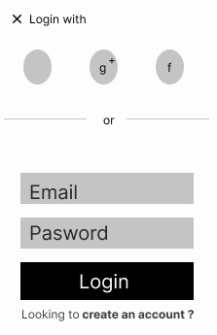

1. **Log out function**

* Card

As a user website, I want to log out, because I don’t want anyone to not use my account.

* Conversation
* A user had a valid account to log in successfully and logout
* Button: “logout”
* After logout, no one can access and use the functions of this account
* Confirmation
* The system will lead to a login page
* Users must log in again to use the functions
* Scenarios:

1. Click on account Gmail
2. Choose logout.
3. **Registration function**

* Card

As a new user, I want to register a new account so that I can use it to login later on.

* Conversation
* Registration information:
* Required field: email, password

When a user loses an account, providing this information may help recover the account.

+ Button: “Register”

+ Notification: register successfully, please wait for the admin to confirm

+ Prompt alert if the user enters invalid data.

+ After being accepted for the registration, the user will log in again to access the website.

* Confirmation
* adds a new user to the database with valid data.
* Prompt corresponding errors and focus on invalid data that put into data field:

Email, password: cannot be empty.

Email: correct email format or already exist

Password: Minimum 6 characters and not exceed 25 characters.

* user access to registration from the login page.
* Scenarios

1. Open the register page

2. Enter email, password

3. Click the “Register” button.

Mockup for register account

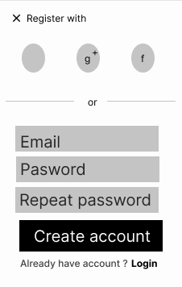

1. **View product**

* Card

As a user, I want to view all the products on the website

* Conversation
* Product information: product image, product name, price, categories, description.
* Add product to cart: product name, quantity.
* Confirmation:
* user access to the website can see the product
* Customers can see the product without logging in.
* Scenarios

1. Open homepage
2. Choose product
3. Click the “add to cart” button.

